GRA 116 Iconography - Final Paper
2016-17 Spring Term
Important remark: Copy-paste may be the easiest way of writing an answer but it is not the right and ethical way. Therefore what I strongly suggest that you read the sources you find and write down your answer just as you were in a test. But don’t forget to check your data is correct! So the text will be your own, reflecting you the best way possible.
Q 1. The painting “Guernica” by Pablo Picasso is one of the most powerful work of art in terms of representing the destructions of war. Please analyze the painting from the iconographical point of view and name 2 (two) other paintings with the subject-matter focusing on the destructions of war. (Min. 200 - Max. 300 words) (40 points)
Q 2. Below is a painting by Botticelli entitled “Venus and Mars” (c. 1483). Please discuss the subject-matter of the painting and artist’s approach from iconographical point of view. (Min. 200 - Max. 300 words) (30 points)
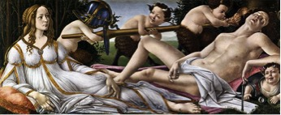
Q 3. “The Crucifixion” is one of the most popular topics in Christian art. Below is the painting by Mantegna (1457-59). The painting depicts most of the literal elements mentioned in the biblical texts. Please discuss those elements that appear in the painting. (Min. 200 - Max. 300 words) (30 points)
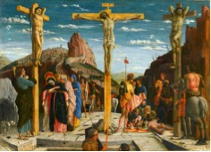

Notes:
Min. 200 - Max. 300 words for each question.
Font is Times New Roman and the font size is 12 pts.
On top of the first page, name, surname, student’s number and the department will be written.
No need for fancy dossier. Just a stack of stapled A4 papers is enough.

Proposed bibliography:
Through following link library.yasar.edu.tr you may reach valuable sources at “jstor”, “ebrary” etc.
Academia is another site at which you may find quite useful articles.
And below is some sources in Turkish:
Gombrich, E. Sanatın Öyküsü, 6. Basım İstanbul: Remzi Kitabevi, 2009
Bell, J. Sanatın Yeni Tarihi.İstanbul: NTV Yayınları, 2009
Turani, A. Dünya Sanat Tarihi, 4. Basım. İstanbul: Remzi Kitabevi, 1992
Tansuğ, S. Resim Sanatının Tarihi, 2. Basım. İstanbul: Remzi Kitabevi, 1993
İpşiroğlu, N. ve M. İpşiroğlu. Oluşum Süreci İçinde Sanatın Tarihi. 3. Baskı. İstanbul: Hayalbaz Yayınevi, 2009
Lynton, N. Modern Sanatın Öyküsü, 4. Basım İstanbul: Remzi Kitabevi, 2009
Antmen, A. 20. Yüzyıl Batı Sanatında Akımlar. İstanbul: Sel Yayıncılık, 2008

Citation:
Please write down the references you’ve used after each question.
First citation: Gombrich, E. Sanatın Öyküsü, İstanbul: Remzi Kitabevi, 2009, p. 120
Citation of the internet sites:
URL address and the date of access.
Example: www. louvre.fr, 10.11.2012
Important remark:
Citation from popular cites and Wikipedia/Vikipedia will not be accepted as reliable sources.
You are expected to use scholarly written books/articles as well as the cites of the museums.
Wish you good luck!
Assist. Prof. Mehmet Kahyaoğlu

